MANIPULARE: Papa şi Rockefeller
Trezirea conştiinţei – blog
În acea zi si ora cand se va întoarce Fiul omului nimeni nu știe. Cu toate acestea, ea va fi în curând
http://mauisaac.blogspot.ro/2015/10/francisco-besa-la-mano-david.html

Despertando Consciencias
Por que el día y la hora en que ha de volver el Hijo del hombre nadie la sabe. Sin embargo, será proximamente

jueves, 15 de octubre de 2015

¿Francisco besa la mano a David Rockefeller, Jonh Rothschild y Henrry Kissinger?

Este aceasta sărutări Francisco mâna lui David Rockefeller, Rothschild și Henrry Jonh Kissinger?
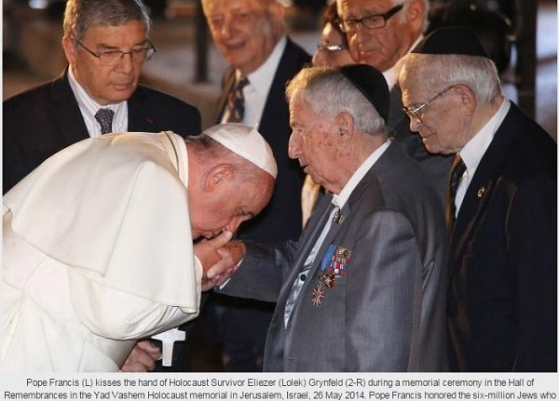
Aceasta este imaginea cu numele real al persoanei Francisco sărută mâna, un om al cărui nume este Eliezer (Lolek) Grynfeld, care pretinde este un supraviețuitor al Holocaustului.
O notă din partea directorului Noua acțiune sunt umane și apere cu pasiune dezvaluit fața swashbuckling și principiile în care credem și au fost întotdeauna dispuși să dea totul, inclusiv viața; dar aceste principii sunt respectate, adevărul întotdeauna și niciodată, utilizați NICIODATĂ minciuna pentru a sprijini argumentele noastre. Aceasta a fost premisa de viața mea și ca un om am-atunci când am făcut o greșeală, nu a fost niciodată rezultatul de rea-credință sau greșit în mod intenționat. Internetul este folosit de mai multe persoane pentru a denatura evenimente sau producerea de fals "știri" . În ultimul nostru problemă, am publicat în secțiunea = o mie de cuvinte o imagine a Papei Francisco saruta mâna unei persoane de la partea de jos a fotografiei, spunând în limba franceză care persoana căreia sărutări Papei mâna este David Rockefeller și o altă persoană identificată ca John Rothschild. Cineva bine, după o căutare am găsit schimbat legende și oamenii care intampina Francisco și sărută mâna nu sunt enumerate în răspândirea foto.

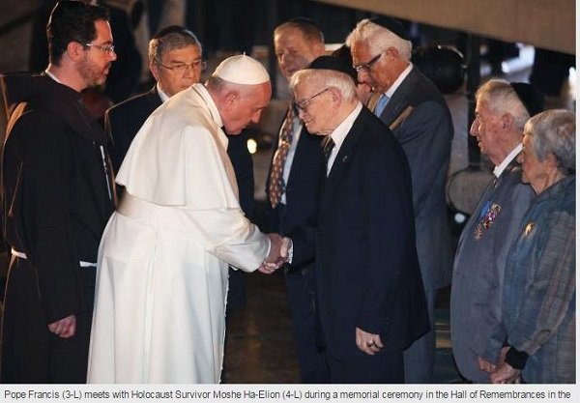
În această imagine a identifica-a spus în mod fraudulos, care fotografia fals cu piciorul în limba franceză, a fost John Rothschild cu numele său real Moshe Ha-Elian,

Avem fotografii originale și cere scuze cititorilor nostri, vom publica astazi identificarea persoanelor care apar alături de Papa. Fotografiile au fost realizate la 26 mai 2014 la Memorialul Holocaustului din Ierusalim. Noi nu sunt infailibile și că fotografie a fost trimis la noi de către persoanele ne respectăm-suntem siguri că acestea nu au fost constienti de mișcare și, prin urmare am crezut că era adevărat ceea ce au spus ei. Din nou!, Am exclamat Mea Culpa Mea Culpa Mea Culpa!,!, Dar la fel de buni creștini și jurnaliști grave, își asumă consecințele greșeală nostru și fotografiile publicate astăzi cu detalii privind locul în care ceremonia era adevărata identitățile oameni care apar cu Papa Francisco.
Postat de către Enrique Sierra Mendoza la 01:27:00
VEZI MAI ALES ŞI
http://www.vosizneias.com/165916/2014/05/27/new-york-my-opinion-a-proper-perspective-the-pope-and-the-jewish-people/
Welcome, Guest! - Sign-In or Create an Account

New York - My Opinion: A Proper Perspective - The Pope And The Jewish People
Published on: May 2By: Ezra Friedlander Published on: May 27, 2014 12:01 PM
7,
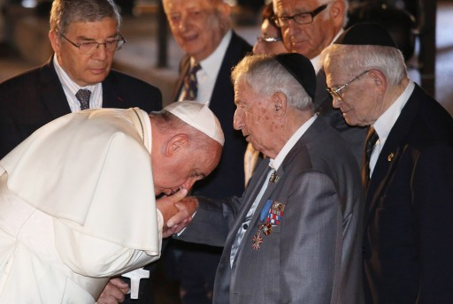
Pope Francis (L) kisses the hand of Holocaust Survivor Eliezer (Lolek) Grynfeld (2-R) during a memorial ceremony in the Hall of Remembrances in the Yad Vashem Holocaust memorial in Jerusalem, Israel, 26 May 2014. EPA
New York - As the Pope has left Israel, it’s time for us to reflect on his visit and the impact it has had on the Jewish people worldwide.
Reflections on a visit of this magnitude are never easy, for the ramifications are difficult to predict. But of one thing I am certain. The Jewish people are better off for it.
It’s now seventy years since the cattle cars ran to Auschwitz at full capacity and the world was silent. At that time, even the Vatican insisted on maintaining ‘neutrality’ and the debate continues to rage until today on whether the Pope did enough to save the Jews.
But now we have a Pope who is visiting the State of Israel accompanied by an Orthodox Rabbi who has worked with him for decades.
I wonder if some of us are living in a cocoon, unable to recognize the enormous, indeed epic, goodwill that this visit has generated. In an instant transmission of image and intent, the Pope’s visit to Israel has resulted in sending the powerful message that the leader of 1.2 billion Catholics is a friend of the Jewish people worldwide. He has unequivocally denounced terrorism, sending a signal to all those who cherish life that a religious leader with the unparalleled status of the Pope has publicly declared a kinship with the Jews.
To all those who don’t understand or appreciate the significance of this, I say: There was a time when Priests would rile up anti-Semitism—Thank G-D that is no longer the case. I agree it’s important to remember and recognize Christian persecution of the Jewish people throughout the millennia. But we also have the responsibility to behave appropriately and respectfully when the leader of the Roman Catholic Church visits the homeland of the Jewish people, denounces terrorism, embraces Holocaust survivors, makes a plea for peace, and connects emotionally with the Jewish people.
We are a nation small in numbers. Goodwill goes a very long way.
I have seen the criticisms against those who are welcoming the Pope and I find that disapproval to be the result of a small minded world view.
Unfortunately, in this technologically advanced age, even this minority dissenting opinion can reach millions and can convey the mistaken impression that this is mainstream thought.
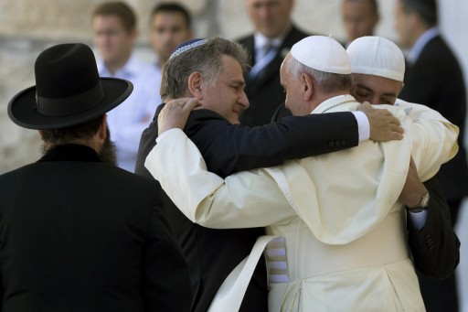Pope Francis (2-R) embraces his friends from Argentina, Rabbi Abraham Skorka (2-L) and Argentine Muslim leader Omar Abboud (R) as the Rabbi of the Western Wall Shmuel Rabinovitz looks on (L), after the Pope prayed and placed a note into the Wall, Judaism’s holiest site, in Jerusalem, Israel, 26 May 2014. EPA
Hopefully my words today will allow level headed people to realize that a visit from the Pope is akin to a visit of a head of State. Historically, we owe him respect. Back in Europe, Rabbonim of great stature would welcome a visiting dignitary with a Sefer Torah as a gesture that underscored the proper recognition given to someone in a powerful position. In fact, the Vatican is a sovereign entity that enjoys diplomatic relations like other nations do. The Pope is essentially the leader of over a billion followers who look up to him with reverence, and he deserves to be welcomed with respect. We would want no less for our own leaders if the tables were turned.
We see that even great sages in the Talmud understood and displayed great sensitivity regarding interactions with non-Jews: The Talmud in Berachot 17a.) discusses that Rabbi Yochanan Ben Zakai always did manage to greet everyone in the market “first” including non-Jews.
I will not attempt to make analogies to the subject at hand but it is self understood that when a Pope who is the revered leader of a billion people visits it is obligatory to show proper respect.

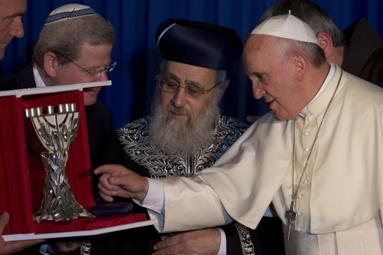Pope Francis exchanges gifts with Israel Rabbi Yitzhak Yosef, centre) during the meeting of the two religious leaders in Jerusalem, Israel May 26, 2014. EPA
We live in a world where threats to the Jewish people abound. We have seen it in Brussels and we have seen it in Brooklyn as well. Why should a Catholic in New York or anywhere else sense that we have not treated their leader with respect? Are we prepared to consider the damage that could chas v’sholom occur?
Here in America, we are blessed with unprecedented freedom and protection. But that same status isn’t enjoyed universally. There are those who are living in fear of anti-Semitic attacks So when we welcome a Pope to the State of Israel there should be a wall to wall warm welcome without dissension. The people of the shtetl understood this. Why can’t we?
We certainly are entitled to disagree about church policies. And we are certainly permitted to express our opinions. But at the same time we must understand that the Pope’s visit is both historic and humbling to the Jewish people. Especially this specific Pope who has shown himself to be our friend decades before his election as the leader of the Catholic church. I have firsthand knowledge of the Pope’s relationship with the Jewish community in Buenos Aires in which he demonstrates a deep and sensitive friendship.
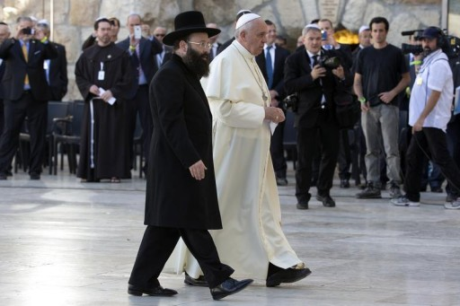Pope Francis and the Rabbi of the Western Wall Shmuel Rabinovitch walk towards the Western Wall, Judaism’s holiest prayer site, in Jerusalem’s Old City May 26, 2014. Reuters
And lest we think that what happens overseas and six thousand miles away has zero impact on us, I assure you it does. The Jewish community and the Catholic community have much in common, most notably the parochial schools in which we teach our children. We share a common goal in working to alleviate the cost of tuition in constitutionally permissible ways. Hence, a coalition has been formed over the decades between our communities as we seek out ways to help parents who are struggling with tuition payments.

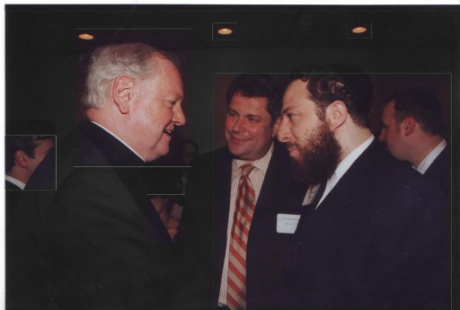
FILE - Ezra Friedlander in a conversation with Cardinal Egan, in 2008.
Back in 2008, I recall having a conversation with Cardinal Egan, then of the Archdiocese of New York, in which he passionately expressed his feelings about this issue. At the time, my firm was coordinating an event on behalf of TEACH-NYS, a strong coalition of Jewish and Catholic school leadership. The Cardinal took the trouble of traveling to Albany several times because he felt so strongly about this. Ultimately the efforts paid off and an unprecedented child tax credit was voted in, benefiting Yeshiva parents as well. This came about primarily as a result of the strong coalition that existed between Jewish and Catholic school leaders. Imagine if we would have foolishly jeopardized that relationship back then!
Let’s remember that respecting others is a basic tenet of our faith. We are not advocating for anyone to deviate from our traditions or our customs, merely to respect the beliefs of others. Let’s remember that words are very powerful and that actions often cause reactions. So let’s choose our words carefully, both publicly and privately. And let us hope that the Pope’s visit will help to usher in an era of peace and tranquility for the Jewish people around the world.
Ezra Friedlander is the CEO of The Friedlander Group, a public policy and government relations firm based in New York City and Washington DC. He can be contacted at ezra@thefriedlandergroup.com
Şi http://sarahhonig.com/2014/05/28/a-small-tragedy/

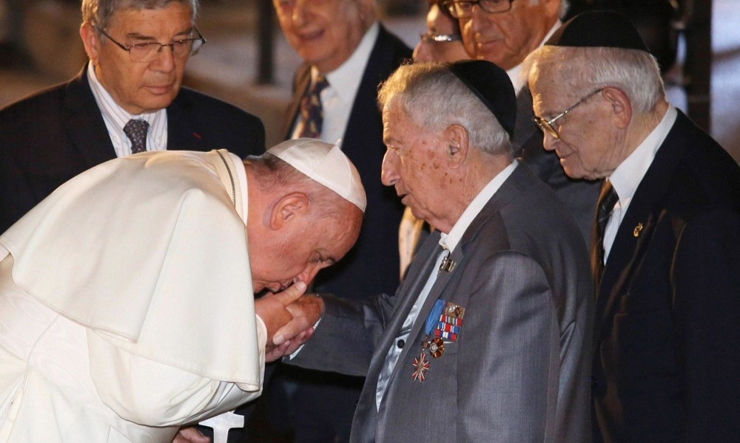
PublishPapa Francesco bacia la mano a Eliezer (Lolek) Grynfeld, sopravvissuto all' Olocausto. Gerusalemme, 26 maggio 2014
Credits: ANSA /EPA /Abir Sultaned
http:/
http://www.panorama.it/news/marco-ventura-profeta-di-ventura/papa-francesco-terra-santa/#gallery-0=slide-1

ARGUMENTE:
https://resistanceauthentique.wordpress.com/2015/09/30/le-pape-francois-embrasse-la-main-de-david-rockefeller-john-rothschild-et-henry-kissinger/

PRECUM ŞI

Poison-Quotidien.
"Dieu se rit des hommes qui déplorent les effets dont-ils chérissent la cause" Jacques-Bénigne BOSSUET

mercredi 30 septembre 2015

Le Pape François ( de l'ordre des jésuites) embrasse la main de survivants de l'holocauste entouré de ses maîtres mondialistes, Henry Kissinger, entre autres. Victoire totale de la Synagogue de Satan, Rothschild et Rockefeller.
Ah, la (les) religion (religions) ! Quelle belle invention pour séparer, mettre en concurrence et foutre la merde entre les convaincus de si et les convaincus de ça. Moi, qui suis Pierre Hillard depuis des années, je ne comprends toujours pas comment le Catholicisme a pu s'emparer de lui (en sachant tout ce qu'il sait) ! Probablement adhère t-il aux valeurs anciennes du catholicisme (?).

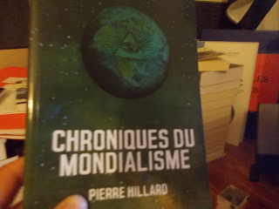
Évidemment, le catholicisme, depuis Vatican II, n'a plus rien de catholique. Mais, quand même, posez vous la question suivante : qui est derrière la religion catholique (et les autres d'ailleurs) ? En cherchant un peu vous trouverez très facilement. Pour vous aider, très légèrement, voici ce que dit le peuple élu (ancien testament démoniaque) du catholicisme : "depuis Vatican II, le catholicisme est devenu le catholicisme d'Israël". Tout est dit, ou presque.

Comme dirait la personne qui m'a ouvert un œil sur ce système satanique (elle se reconnaîtra) : "la vraie foi se trouve dans le cœur, pas besoin de Vatican ou autres représentations".

Et "le Pape" dans tout cela ?
Le voici "le Pape", post Vatican II, aux ordres de ces maîtres !

Obéis !
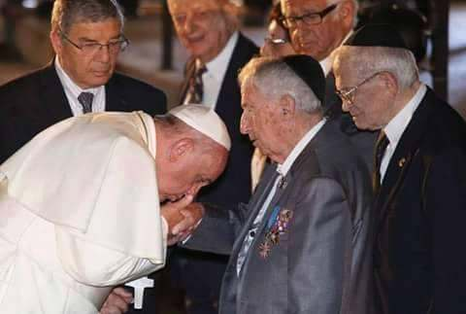
La guerre, entre l'Église et la Synagogue, est bien réelle. Mais pour qui ? !!
Il est possible d'essayer de comprendre cette guerre en étudiant MGR H. Delassus (docteur en théologie), en autres. Ce livre donne les clefs pour bien comprendre les effets indésirables (révolution Française, Franc-maçonnerie, les lumières, les encyclopédistes, la Synagogue de satan, etc., etc., etc.) de la conjuration antichrétienne.
Attention : c'est un très gros pavé (1500 pages environs !).

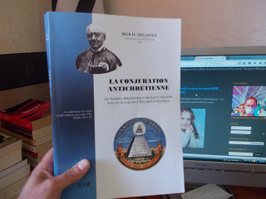
http://www.alterinfo.net/Le-pape-Francois-embrasse-la-main-de-David-Rockefeller-John-Rothschild-et-Henry-Kissinger_a117637.html
http://free.niooz.fr/site/281/stopmensonges-com
http://wordpress.catholicapedia.net/apres-santo-subito-jp%C2%B2-et-benoit-francois-defie-la-colere-de-dieu-au-mur-des-lamentations/
Publié par Poison-Quotidien à 05:19

VIDEO: Pope Francis Visits Yad Vashem
https://www.youtube.com/watch?v=XbHMIKnD0cE

ŞI http://www.nuevamentes.net/2015/10/le-pape-satanique-francois-embrasse-la.html
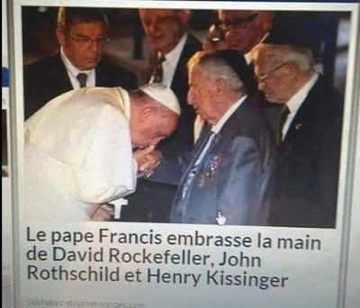
Religia a fost întotdeauna o cârjă pentru capitalism. Documente justificative pentru cei care nu sunt încă convinşi: Francisc sărută mâna dreaptă lui Rockefeller, Rothschld şi Kissinger. Marii magnaţi ai sistemului sclaviei moderne în faţa cărora se pleacă Papa…

- Personalisez ce menu avec vos sujets favoris
Ajouter
http://free.niooz.fr/le-pape-francis-embrasse-la-main-de-david-rockefeller-john-rothschild-et-henry-kissinger-4034769.shtml

Sur le meme sujet
resistanceauthentique.wordpress.com 30/09/2015
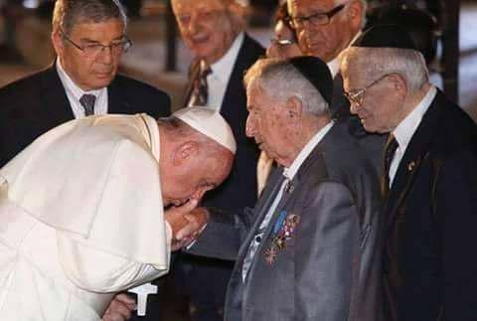

Le pape Francois embrasse la main de David Rockefeller, John Rothschild et Henry Kissinger !! EN COURS …
StopMensonges.com 29/09/2015

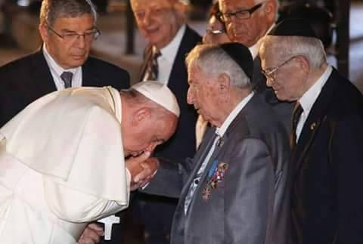

Le pape Francis embrasse la main de David Rockefeller, John Rothschild et Henry Kissinger
StopMensonges.com 29/09/2015

Le pape Francis embrasse la main de David Rockefeller, John Rothschild et Henry Kissinger
France TV 27/02/2014

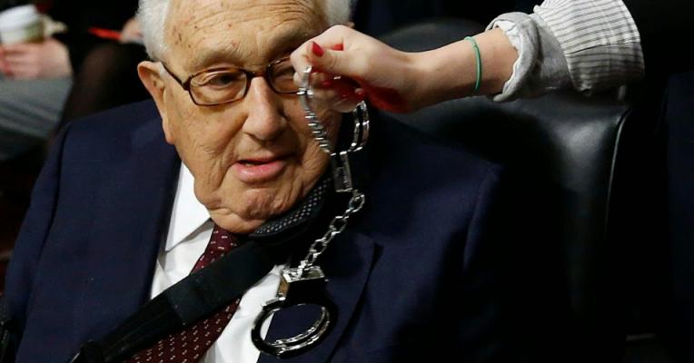

Les crimes de guerre d'Henry Kissinger
Le Figaro 29/06/2014

Joyeux Anniversaire David Rockefeller
publié par alterinfo.net le mercredi 30 septembre - 12h01

Le pape Francois embrasse la main de David Rockefeller, John Rothschild et Henry Kissinger

La religion a été toujours une béquille pour le capitalisme. Preuve à l'appui pour ceux qui ne sont pas encore convaincus : Le pape Francis embrasse la main de David Rockefeller, John Rothschild et Henry Kissinger sur la droite...Des grands magnats du sys

http://www.boursenews.ma/actualites/dernieres-infos/j-aime-ma-banque
http://aneaglessight.blogspot.ro/2014/06/pope-francis-pushes-for-one-world.html
http://vremuritulburi.com/category/catolicism/page/2/
http://meritocratia.ro/2015/05/actualitatea-romaneasca-14-05-2015/
https://lumeacarnavalului.wordpress.com/page/3/
https://lupuldacicblogg.wordpress.com/2015/06/02/sase-milioane-de-minciuni

http://pirate-972.skyrock.com/3261816598-NOUVEL-ORDRE-MONDIAL-SATANIQUE-IMMINENT-Le-pape-satanique-Francois.html

NOUVEL ORDRE MONDIAL SATANIQUE IMMINENT ! Le pape satanique Francois embrasse la main de c est supérieurs David Rockefeller, John Rothschild et Henry Kissinger
Mercredi 30 Septembre 2015
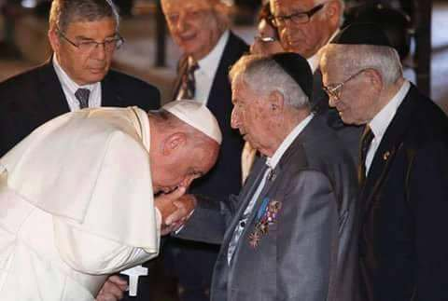
La Religion a été toujours une béquille pour le capitalisme. Preuve à l'appui pour ceux qui ne sont pas encore convaincus : Le pape Francis embrasse la main de David Rockefeller, John Rothschild et Henry Kissinger sur la droite...Des grands magnats du système d'esclavage moderne devant lesquels le pape se prosterne.
Il n'y a rien a esperer d'un pape jésuite
https://www.stormfront.org/forum/t1057837-126/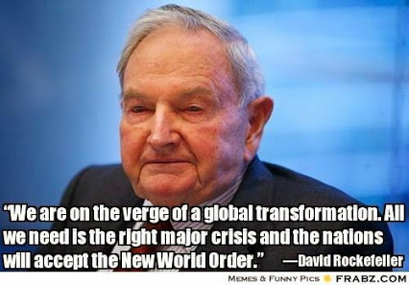
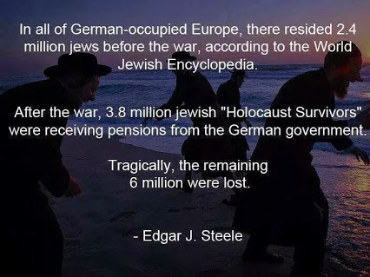

http://www.lovendal.ro/wp52/absolut-socant-papa-francisc-ii-pupa-mana-lui-david-rockefeller-unul-din-liderii-illuminati-daca-nici-aceasta-poza-nu-v-a-convins/

https://aldoror.fr/2018/12/27/propager-le-mensonge-et-la-haine/*

